EYE Sensor Protocol overview

Sensor advertising

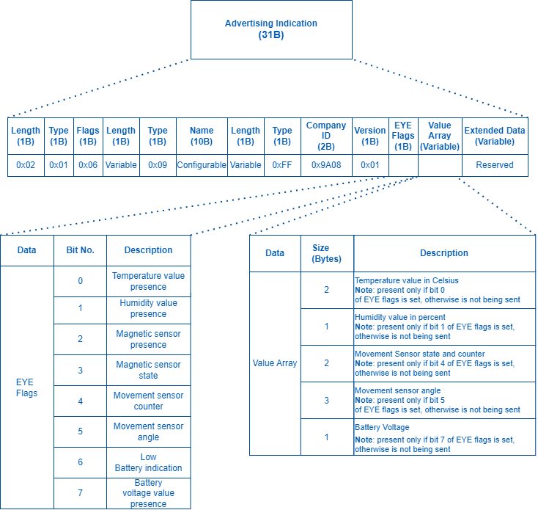

Beacon and sensors data
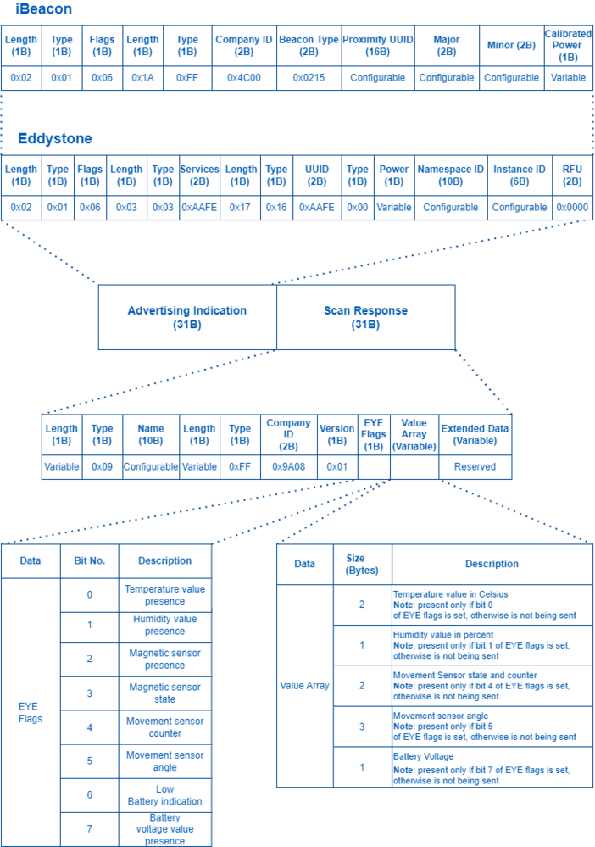

Protocol description
At the highest-level Bluetooth® LE advertising packet consists of Advertising Indication and Scan Response. Both packets can be maximum of 31 bytes in size. Advertising Indication packet is always broadcasted when Scan Response is broadcasted only if Observer device requests it by using Active Scan.
BTSMP1 uses Advertising Indication to send beacon data which can be configured to select between iBeacon and Eddystone protocols or to be disabled at all. In that case, data which is shown as Scan Response in protocol overview will be sent as Advertising Indication without Scan Response following it.
Scan Response is used to send device name and manufacturer specific data. Manufacturer specific data includes Teltonika Company ID (0x089A) and protocol version (0x01). It is followed by Flag Encoded Data (Table 1) and Extended Data (Table 2). Later on, protocol will be highly configurable in and will allow to disable/enable sending of device name or any sensor value allowing to reduce size of the packet being sent.
Teltonika BTSX devices are transmitting one or two packets depending on the selected protocol. Broadcast packet + Scan response packet.
A scan response packet is sent when an active scan is used, within the BLE layer of communication. The default for our FM devices and many other applications for example our EYE Appication or nRF connect Application is an active scan.
There are three protocols, with the following packets:
1.iBeacon + EYE Sensors
2.Eddystone + EYE Sensors
For iBeacon + EYE Sensors and Eddystone + EYE Sensors protocols only iBeacon/Eddystone packet is broadcasted and will be seen by both active and passive scans, to see the EYE Sensors packet you need to use an active scan. In other words in an environment where no BLE devices are scanning with an active scan or in case when there are no scanning devices at all, only the iBeacon/Eddystone packet will be sent by the BTS device to conserve energy.
3. EYE Sensors
With EYE Sensors protocol, the EYE Sensor packet becomes broadcast. In other words, in an environment where no BLE devices are scanning with an active scan or in case when there are no scanning devices at all EYE Sensors packet will be sent by the BTS device.
More Information on Active vs passive scans
Device Name has the following default value for Beacon – ID1_XXXXXXX
Table 1. Flag Encoded Date
Data | Size (Bytes) | Description
Flags | 1 | Each set bit (0-7) means the presence of value (0-7). Bits:  0 – Temperature value presence  1 – Humidity value presence  2 – Magnetic sensor presence  3 – Magnetic sensor state (1 magnetic field is detected/0 magnetic field is not detected) Valid value is present only if bit 2 flag is set.  4 – Movement sensor counter  5 – Movement sensor angle  6 – Low Battery indication (if set to 1 low battery voltage detected)  7 – Battery voltage value presence
Value 0 | 2 | Temperature  Value in Celsius / 100  NOTE: present only if bit 0 is set, otherwise is not being sent
Value 1 | 1 | Humidity  Value in percent  NOTE: present only if bit 1 is set, otherwise is not being sent
Value 2 | 2 | Movement Sensor counter  Most significant bit indicates movement state and 15 least significant bits represent count of movement events.  NOTE: present only if bit 4 is set, otherwise is not being sent
Value 3 | 3 | Movement sensor angle  Most significant byte – pitch (-90/+90)  Two least significant bytes – roll (-180/+180)  NOTE: present only if bit 5 is set, otherwise is not being sent
Value 4 | 1 | Battery Voltage  Battery voltage in mV = 2000 + VALUE * 10  NOTE: present only if bit 7 is set, otherwise is not being sent

GATT Characteristics
Name | Service UUID | Characteristic UUID | Data Type | Min | Max | Default Value | Notes
Device Name | e61c0000-7df2-4d4e-8e6d-c611745b92e9 | e61c0016-7df2-4d4e-8e6d-c611745b92e9 | ASCII | 0 | 12 | Unique for each device | -
Tx Power Lever | 1804 | 2a07 | SINT8 | -14 | 8 | 2 | Possible values: -14, -11, -8, -5, -2, 2, 4, 8
Protocol Type | e61c0000-7df2-4d4e-8e6d-c611745b92e9 | e61c0001-7df2-4d4e-8e6d-c611745b92e9 | UINT8 | 0 | 4*  *Max 2 with 01.02.10+ firmware | 1 for EYE_Beacon,  4 for EYE_Sensor*  *with 01.02.10+ firmware 1 for both EYE_Beacon & EYE_Sensor | 0 - iBeacon  1 - Eddystone  2 - EYE Sensor  3 - iBeacon + EYE Sensor*  4 - Eddystone + EYE Sensor*  *01.02.10+ sensors are enabled over Activate / Deactivate Sensors
Activate / Deactivate Sensors*  *from 01.02.10+ firmware | e61c0000-7df2-4d4e-8e6d-c611745b92e9 | e61c0021-7df2-4d4e-8e6d-c611745b92e9 | UINT8 | 0 | 15  (0b1111) | 4 (0b0100) for EYE_Beacon,  15 (0b1111) for EYE_Sensor | (LSb) bit 0 – Temperature  Bit 1 – Humidity  Bit 2 – Magnetic  Bit 3 - Movement  E.g. EYE_Sensor disabled movement & enabled temperature, humidity, magnetic sensors 7 (0b0111)
Advertising Interval | e61c0000-7df2-4d4e-8e6d-c611745b92e9 | e61c0002-7df2-4d4e-8e6d-c611745b92e9 | UINT16 | 1000 | 10000 | 5000 | miliseconds
Sub Advertising Interval | e61c0000-7df2-4d4e-8e6d-c611745b92e9 | e61c0003-7df2-4d4e-8e6d-c611745b92e9 | UINT16 | 20 | 1000 | 100 | Used by repeats, miliseconds
Advertising Repeats | e61c0000-7df2-4d4e-8e6d-c611745b92e9 | e61c0004-7df2-4d4e-8e6d-c611745b92e9 | UINT16 | 1 | 10 | 1 | Repeats work only if Advertising Interval is more than 2000 ms and Repeats set to more than 1
iBeacon ID | e61c0000-7df2-4d4e-8e6d-c611745b92e9 | e61c0005-7df2-4d4e-8e6d-c611745b92e9 | BYTE ARRAY | 20 bytes | 20 bytes | Unique for each device | 16 B - UUID  2 B - major  2 B - minor
Eddystone ID | e61c0000-7df2-4d4e-8e6d-c611745b92e9 | e61c0006-7df2-4d4e-8e6d-c611745b92e9 | BYTE ARRAY | 16 bytes | 16 bytes | Unique for each device | 10 B - Namespace  6 B - Instance
Command | e61c0000-7df2-4d4e-8e6d-c611745b92e9 | e61c0007-7df2-4d4e-8e6d-c611745b92e9 | Command characteristic
Password | e61c0000-7df2-4d4e-8e6d-c611745b92e9 | e61c0008-7df2-4d4e-8e6d-c611745b92e9 | BYTE ARRAY | 6 bytes | 6 bytes | 123456 | Always 6 Digits
Movement Start | e61c0000-7df2-4d4e-8e6d-c611745b92e9 | e61c0013-7df2-4d4e-8e6d-c611745b92e9 | UINT16 | 0 | 300 | 5 | seconds
Movement Stop | e61c0000-7df2-4d4e-8e6d-c611745b92e9 | e61c0014-7df2-4d4e-8e6d-c611745b92e9 | UINT16 | 0 | 300 | 5 | seconds
Password Counter | e61c0000-7df2-4d4e-8e6d-c611745b92e9 | e61c0019-7df2-4d4e-8e6d-c611745b92e9 | UINT8 | 0 (counter) | 10 (counter) | 0 | Byte 0 – counter,  Byte 1 and 2 - timeout
Master Password (PUK) | e61c0000-7df2-4d4e-8e6d-c611745b92e9 | e61c0020-7df2-4d4e-8e6d-c611745b92e9 | UINT8 | 8 bytes | 8 bytes | MAC address dependency | Byte array
Manufacturer sleep (Hibernate mode) | e61c0000-7df2-4d4e-8e6d-c611745b92e9 | e61c0018-7df2-4d4e-8e6d-c611745b92e9 | UINT8 | 0 | 1 | 1 | 0 – sleep disabled,  1 – sleep enabled
User ADV Spam Duration | e61c0000-7df2-4d4e-8e6d-c611745b92e9 | e61c0022-7df2-4d4e-8e6d-c611745b92e9 | UINT16 | 1 | 300 | 30 | WakeUp Advertising  Spam Duration in seconds
RSSI Calibration Value | e61c0000-7df2-4d4e-8e6d-c611745b92e9 | e61c0023-7df2-4d4e-8e6d-c611745b92e9 | INT8 | -100 | 127 | 127 | RSSI value in dBm  127 – Use default calib. table
Manufacturer | 180A | 2A29 | BYTE ARRAY | - | - | Not Configurable | Read Only. Ex. "Teltonika"
Model | 180A | 2A24 | BYTE ARRAY | - | - | Not Configurable | Read Only. Ex. "BTSID1"
Serial | 180A | 2A25 | BYTE ARRAY | - | - | Not Configurable | Not used
Hardware | 180A | 2A27 | BYTE ARRAY | - | - | Not Configurable | Read Only. Ex. "Table:1 Volt:325
Firmware | 180A | 2A26 | BYTE ARRAY | - | - | Not Configurable | Read Only. Ex. "1.1.0-beta"
System ID | 180A | 2A23 | BYTE ARRAY | - | - | Not Configurable | Not used
MAC | 180A | 652143dc-dec6-4fb1-bd46-3e919d2410a6 | BYTE ARRAY | 6 | 6 | Not Configurable | Read Only. ex. 112233445566 -> 11:22:33:44:55:66
Calibration ID | 180A | a610249f-913e-46bd-b14f-c6dedc432165 | BYTE ARRAY | 9 | 12 | Not Configurable | Read Only. e.g. 295268313  *Only with EN12830 certified devices
Scan Response Data | e61c0000-7df3-4d4e-8e6d-c611745b92e9 | e61c0001-7df3-4d4e-8e6d-c611745b92e9 | BYTE ARRAY | 17 | 17 | Not Configurable | Scan Response Data, see picture for detail view of data structure
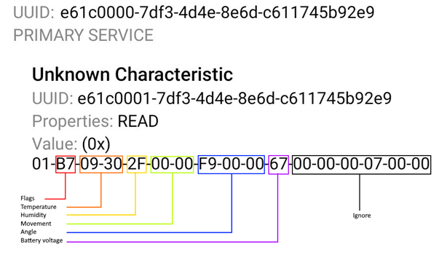

Command characteristic
Command's name | Data to send | Description
Write to flash | 0x0010 | Writes set parameters to flash
General boot | 0x0011 | Enter boot mode
Instant reset | 0x0012 | Software reset
Reset after connection | 0x0013 | Reset after disconnect
Get hw voltage | 0x0014 | Sets detected hw voltage in response data
Keep connection alive | 0x0015 | Resets disconnect timer
Restore defaults | 0x0016 | Sets all configurable parameters to default values

EYE Sensor Bluetooth® frame parsing example
Unparsed Data
0201061AFF4C000215FFFFFFFF0B8C404510C655AAB636EBEFBB700055020C094D50315F313233343536370EFF9A0801B708B4120CCB0BFFC767

Parsed Data
Parameter |  | HEX Code Part | Actual Value
 | Length | 02
 | Type | 01
 | Flags | 06
 | Length | 1A
 | Type | FF
 | Apple company identifier (big endian) | 4C00
 | Beacon type | 0215
 | UUID | FFFFFFFF0B8C404510C655AAB636EBEF
 | Major | BB70
 | Minor | 0055
 | Power | 02
 | Length | 0C
 | Type | 09
 | Device name | 4D50315F31323334353637
 | Length | 0E
 | Type | FF
 | Teltonika company ID (big endian) | 9A08
 | Protocol version | 01
 | Flags | B7 | Raw value example 0xB7. Data has to be interpretated as binary value.  In this example would be (MSB)1011 0111(LSB) and is parsed from least significant byte(LSB).  0 – Temperature value presence. 1 Means device is reading and transmitting temperature value.  1 – Humidity value presence. 1 Means device is reading and transmitting humidity value.  2 – Magnetic sensor presence. 1 Means device is reading and transmitting Magnetic sensor value.  3 – Magnetic sensor state (1 magnetic field is detected/0 magnetic field is not detected) Valid value is present only if bit 2 flag is set.  4 – Movement sensor counter. 1 Means device is reading and transmitting movement state and count values.  5 – Movement sensor angle. 1 Means device is reading and transmitting angle roll and pitch values.  6 – Low Battery indication. 0 – Means device battery is from 100 to 15 % (When value changes to 1 Battery level is lower than 15 %.  7 – Battery voltage value presence. 1 Means device is reading and transmitting battery voltage value.
 | Temperature | 08B4 | Raw value example 0x08B4 hex, 2228 dec.  Raw value needs to be divided by 100.  Real temperature is 22,28 Celsius.
 | Humidity | 12 | Raw value example 0x12 hex, 18 dec.  Decimal value is humidity in percent. Humidity 18 %
 | Movement | 0CCB | (MSB)0000 1100 1100 1011(LSB) binary  0 - Most significant byte(MSB) represents Movement status. In this case device is not moving 0. If it was 1 device is moving.  000 1100 1100 1011 – represent detected movements count 3275 decimal value means device has detected total 3275 movement events,
 | Angle | 0BFFC7 | 0B – Most significant byte represents device pitch. Device pitch can be from -90 to 90 degrees.  In this example device pitch is 0000 1011 (2's complement) = 11° degrees.  FFC7– Two least significant bytes represent device roll. Device roll can be from -180 to 180 degrees.  In this example device Roll is 1111 1111 1100 0111 (2's complement) = -57° degrees
 | Battery voltage | 67 | Battery voltage – raw value example 0x67 hex. Decimal value of parameter 103. To calculate battery voltage need to use calculation 2000 + (VALUE * 10). In this case battery voltage value 2000+(103x10)= 3030 mV

